**Introduction:**

I had to write a function that reads the file and populates the binary search tree with all the English words contained in the file. Ask the user what type of binary search tree he/she wants to use (AVL Tree or Red-Black Tree).

I had to write a method called count_anagrams that does not produce output, but returns the number of anagrams that a given word has. For example, count_anagrams(”spot”) should return 6. Finally, write another function that reads another file that contains words (feel free to create it yourself) and finds the word in the file that has the greatest number of anagrams.

**Proposed solution design and implementation:**

In order of finishing this method first of all I got to copy and paste the zybooks method for RB and AVL tree because I was free to use the implementation for these two types of trees. After that I got to adapt zyBook’s code to include the word and make it the key.

After translating the code into python, I got to understand what the binary search tree works, in order of finishing this lab I got help from my professor Diego Aguirre in order to understand better what to I have to do.

Once I was done with the test cases of my RB and my AVL I was ready to read the file which was hard to transverse because my computer is not as powerful as I imagined.

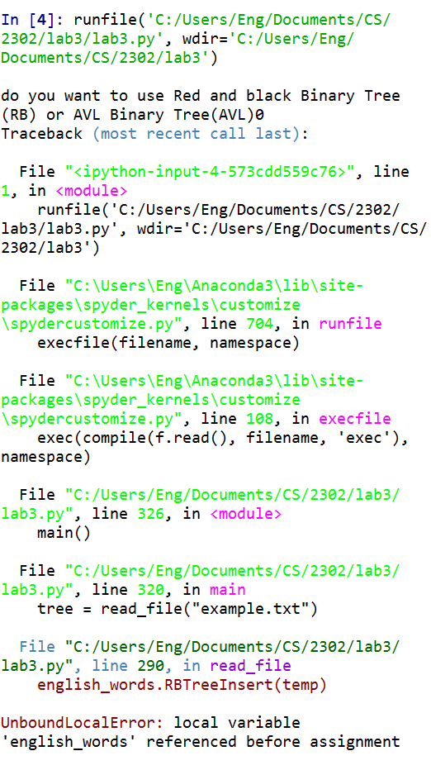**Experimental results:**

I received a problem at first because I did not traverse correctly the RB which gave me a different result from the one I had ; after looking into my code I saw that I had to use ‘’ in order of comparing and input to an actual number

Then I didn’t know how to transverse into the method so I did firstly a base recursive method, then asked my professor if I was on the right way.

After receiving help, I saw that the avl method was wrong because I was putting self inside the method instead of doing self.AVLTreeSetChild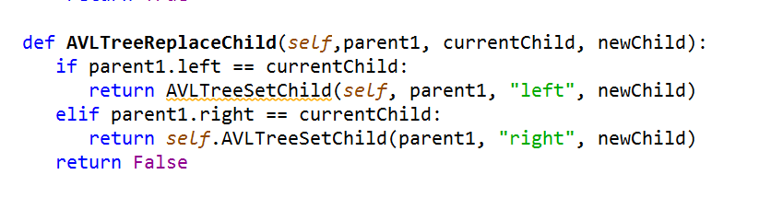

Finally, I went to my solution because I was traversing into the same line of comment and instead of changing it I was only looking for another mistake

**Conclusion:**

I felt really confident at the time finishing my lab because I never taught that I could create my own data structure in order to read file and stored in a better way. Finally my running time was O(logn) for inserting, deleting, and searching in BOTH cases.

**Source Code:** 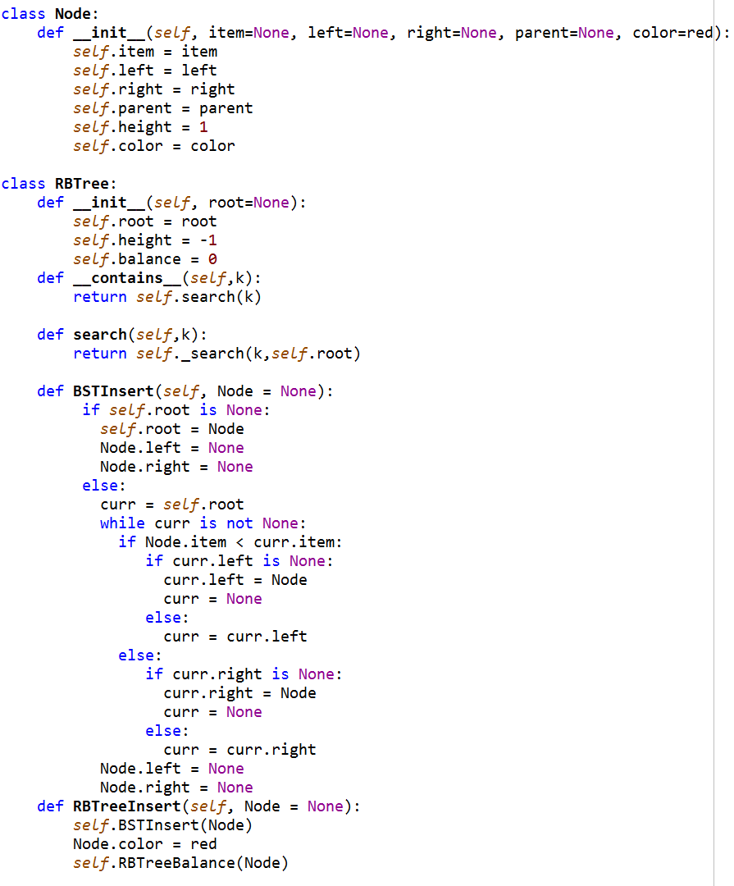

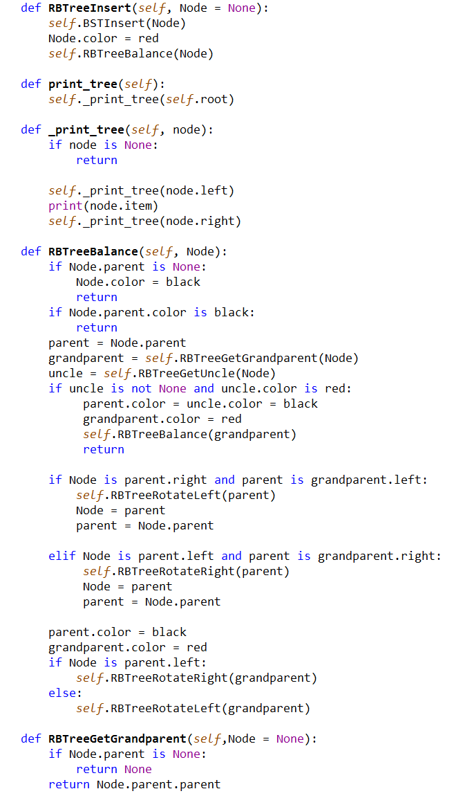 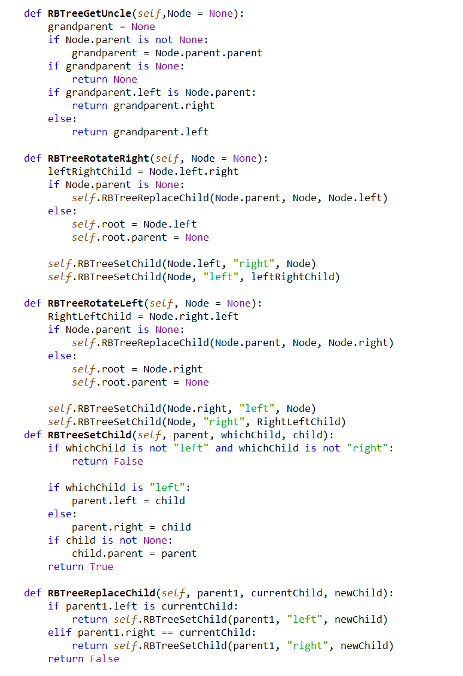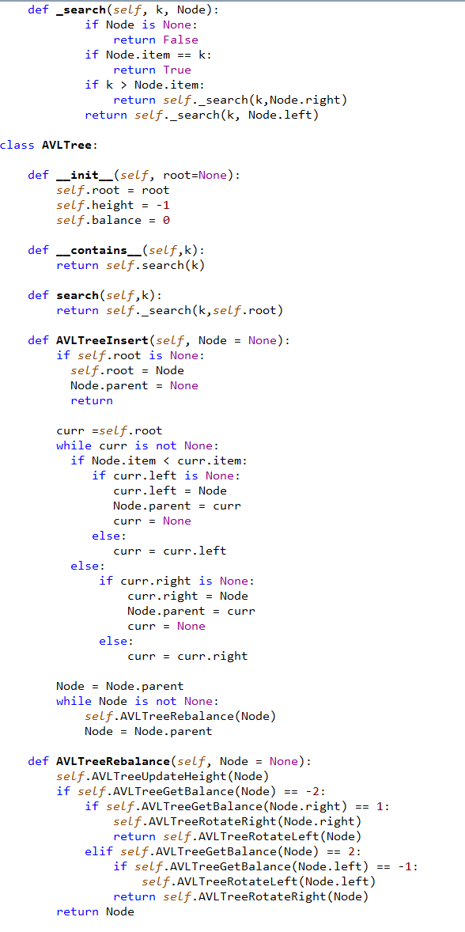 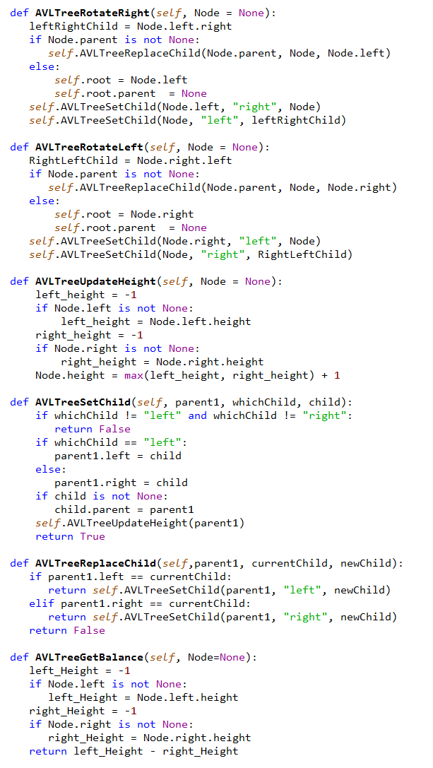

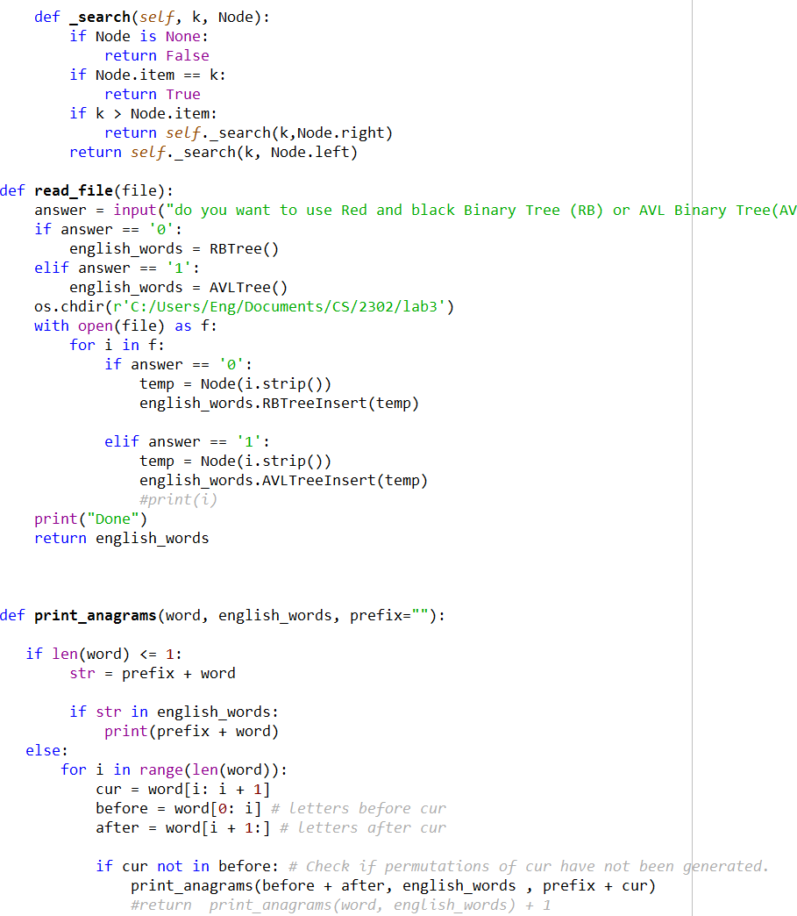

Main

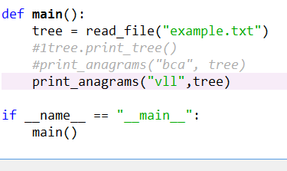

**Academic Honesty**

“I certify that this project is entirely my own work. I wrote, debugged, and tested the code being presented, performed the experiments, and wrote the report. I also certify that I did not share my code or report or provided inappropriate assistance to any student in the class.”